CITY OF HUNTSVILLE, TEXAS
Andy Brauninger, Mayor
Russell Humphrey, Mayor Pro Tem, Ward 2
Daiquiri Beebe, Ward 1
Deloris Massey, Ward 3
Jon Strong, Ward 4
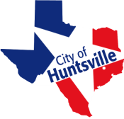
Bert Lyle, Position 1 At-Large
Dee Howard Mullins, Position 2 At-Large
Vicki McKenzie, Position 3 At-Large
Pat Graham, Position 4 At-Large

HUNTSVILLE CITY COUNCIL AGENDA - AMENDED

STRATEGIC PLANNING SESSION
WEDNESDAY, JANUARY 12, 2022, at 5:00 P.M.
THURSDAY, JANUARY 13, 2022, at 5:00 P.M

HUNTSVILLE PUBLIC LIBRARY COMMUNITY ROOM
1219 13TH STREET, HUNTSVILLE, TEXAS, 77340

Persons with disabilities who plan to attend this meeting and may need auxiliary aids or services are requested to contact the City Secretary’s office (936.291.5413) two working days prior to the meeting for appropriate arrangements.

CITY OF HUNTSVILLE CITY COUNCIL SPECIAL WORKSHOP SESSION

Members of City Council will attend and participate in a Strategic Planning Session.

CERTIFICATE
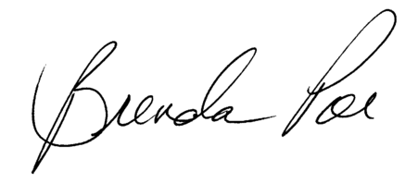
I, Kristy Doll, City Secretary, do hereby certify that the above notice was posted on the City Hall bulletin board, a place convenient and readily accessible to the general public at all times, and to the City’s website, www.HuntsvilleTX.gov, in compliance with Chapter 551, Texas Government Code.

DATE OF POSTING: January 10, 2022 Kristy Doll
TIME OF POSTING: 12:00 p.m. Kristy Doll, City Secretary
TAKEN DOWN:

